Ex No.02 | USES OF CONTROL | Reg.No. URK24CS9068
10.01.25 | STATEMENTS IN PYTHON

1. Write a Python program that takes a student's score as input and assigns a grade based on the
following:
• Score >= 90: Grade A
• Score >= 75: Grade B
• Score >= 60: Grade C
• Score < 60: Grade D
Use if, elif, and else statements to implement this.

Aim: To develop a Python program that accepts a student's score as input and assigns a grade based on predefined criteria using conditional statements.

Objective: To implement a Python program using conditional statements to classify student scores into grades based on predefined criteria.

Algorithm:
Step 1: Start
Step 2: Input the student's score.
Step 3: Check the score using conditional statements:
- If the score is 90 or above, assign Grade A.
- Else if the score is 75 or above, assign Grade B.
- Else if the score is 60 or above, assign Grade C.
- Else, assign Grade D.
Step 4: Display the assigned grade.
Step 5: End

Program:
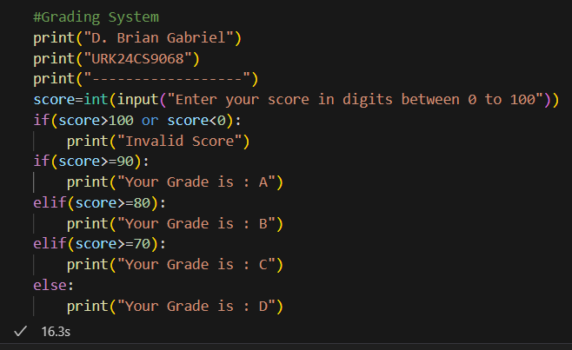

Output:
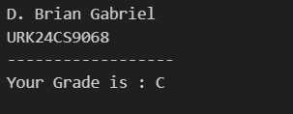

Result:
The Program correctly assigns grades based on the student's score using conditional statements and displays the appropriate grade.

2. Write a Python program that takes a number from the user and checks if it is even or odd. If
the number is even, print "Even", otherwise print "Odd".

Aim: To develop a Python program that takes a number as input and determines whether it is even or odd using conditional statements.
Objective: To implement a Python program using conditional statements to check whether a given number is even or odd.
Algorithm:
Step 1: Start
Step 2: Input a number from the user.
Step 3: Check if the number is divisible by 2:
- If number % 2 == 0, print "Even".
- Else, print "Odd".
Step 4: End
Program:
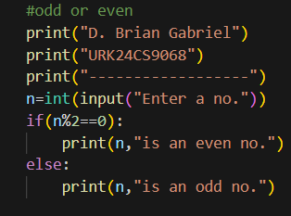
Output:
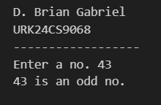

Result: The program correctly determines whether a given number is even or odd and displays the appropriate output based on the user's input.
3. Write a Python program that takes an integer input and checks if it is a prime number. A
prime number is a number that is greater than 1 and has no divisors other than 1 and itself.

Ain: To develop a Python program that takes an integer as input and checks whether it is a prime number using conditional statements and loops.

Objective: To implement a Python program that determines whether a given integer is a prime number by checking its divisibility, using loops and conditional statements.

Algorithm:
Step 1: Start
Step 2: Input an integer from the user.
Step 3: If the number is less than or equal to 1, print "Not a prime number" and stop.
Step 4: Initialize a loop from 2 to (number - 1):
- If the number is divisible by any value in this range, print "Not a prime number" and stop.
Step 5: If no divisors are found, print "Prime number".
Step 6: End

Program:
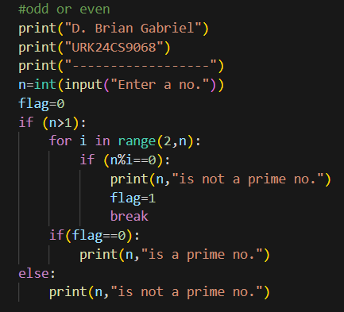
Output:
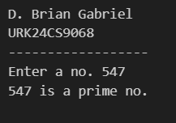

Result: The program correctly determines whether the given integer is a prime number by checking its divisibility and displays the appropriate output based on the user's input.

4. Write a Python program that prints the Fibonacci sequence up to a given number n. The
Fibonacci sequence is defined as:
• 0, 1, 1, 2, 3, 5, 8, 13, 21, ... Use a for or while loop to generate the sequence.

Aim: To develop a Python program that generates and prints the Fibonacci sequence up to a given number n using a loop.

Objective: To implement a Python program that generates the Fibonacci sequence up to a given number n using iterative loops, demonstrating the use of loops and sequence generation.
Algorithm:
Step 1: Start
Step 2: Input the value of n (the limit for the Fibonacci sequence).
Step 3: Initialize two variables:
- a = 0 (first term)
- b = 1 (second term)
Step 4: Print the first two terms (0 and 1).
Step 5: Use a loop to generate the next terms:
- Calculate the next term as next_term = a + b.
- Update a = b and b = next_term.
- Repeat until the next term exceeds n.
Step 6: End
Program:
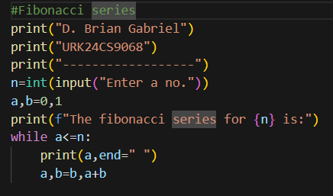

Output:
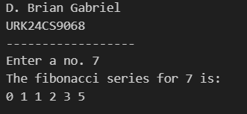

Result: The program successfully generates and prints the Fibonacci sequence up to the given number n, demonstrating the use of loops for sequence generation.

5. Write a program that generates the multiplication table for a given number n. The table
should be displayed for the numbers 1 through 10.

Aim: To develop a Python program that generates and displays the multiplication table for a given number n from 1 to 10 using a loop.

Objective: To implement a Python program that takes an integer input and prints its multiplication table using a loop, demonstrating iteration and arithmetic operations.

Algorithm:
Step 1: Start
Step 2Input the number n from the user.
Step 3: Use a loop to iterate from 1 to 10:
- Multiply n by the loop variable.
- Print the result in the format: n × i = result.
Step 4: End

Program:
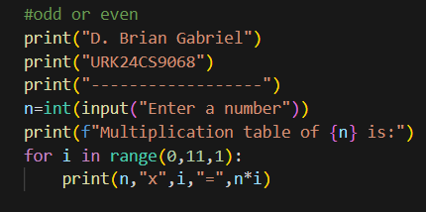

Output:
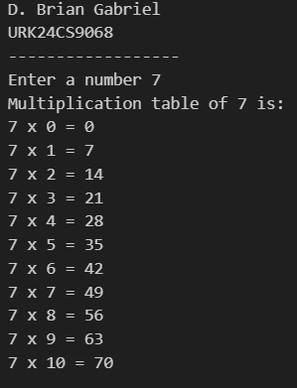

Result: The program correctly generates and displays the multiplication table for the given number n, ensuring accurate calculations using a loop.

6. Write a Python program that takes three numbers as input from the user and finds the largest
among them using if statements.

Aim: To develop a Python program that takes three numbers as input and determines the largest among them using if statements.
Objective: To develop a Python program that takes three numbers as input and determines the largest among them using if statements.
Algorithm:
Step 1: Start
Step 2: Input three numbers from the user as num1, num2, and num3.
Step 3: Use if statements to compare the numbers:
- If num1 is greater than both num2 and num3, print num1 as the largest.
- Else if num2 is greater than both num1 and num3, print num2 as the largest.
- Else, print num3 as the largest.
Step 4: End

Program:
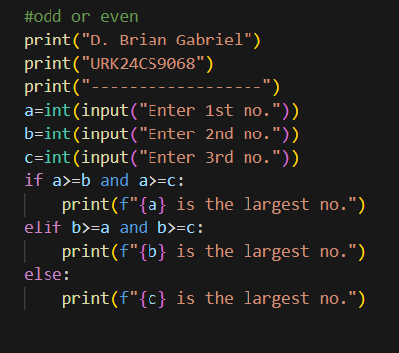
Output:
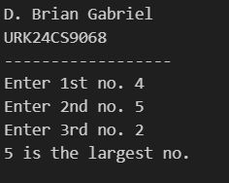

Result: The program correctly identifies and displays the largest number among the three user inputs using conditional statements.

